**SECTION A: OBJECTIVE TYPE QUESTIONS**

Q.1 a) Fill in the blanks:

1. Boolean data type stores ______**Yes/no, True/false**_________ values.
2. While Mail Merging the changing or variable data is stores in document called _______**Source Document**
3. In DBMS Rows are technically called as _________ (**Tuples**)
4. Physical exercise in the form of ____________, ___________________to relieve stress as they stabilize mood, improve self-esteem and induce sleep. **walking, skipping**

Q.2 a) Multiple Choice Questions (6)

1. A __________ operating system is a computing environment that reacts to input within a specific period of time.

a. Single User b Multi-User c. **Real Time** d. Distribute

1. What data type(s) can be used to store photos, music files in a database Base?

|  |  |  |  |
| --- | --- | --- | --- |
| (a) **Binary[VARBINARY**] | (b) | Yes/No[BOOLEAN] | (c) BigInt |
| (d) Number[NUMERIC] | (e) | Text[VARCHAR] |  |

1. _____________ is designed to help users with auditory impairments.

(a)Filter Key (b) Toggle Keys (c) **Sound Sentry** (d) Serial Key

1. ____________ provide Internet access by transmitting digital data over wires of a local telephone network
2. WiMax b) Dial up **c)DSL** d) None of these
3. A ________ tool is an analysis tool that calculates backwards to obtain an input that would yield a given output

a) What-if analysis b) Scenario c) Subtotal d) **Goal seek**

vi __________ helps to move, rotate or resize multiple objects in a presentation.

a **Grouping**  b. Charts c. Table d. Movie clip

How many origins can have stress causal? Answer: Mental, Physical, Social, Financial.

What are document templates? State the purpose of using document template.

Ans : Templates or document templates refer to a sample fill-in-the-blank document that can help in saving time. Usually templates are customized documents that may have sample content, themes, etc. For example, if you want to create a resume you can use a resume template and modify only the sections that require changes.

Ananya uses Internet for her School Project. Suggest any five security measure to ensure safety from online threats

Five safety measures :

Use antivirus and antispyware software, Use strong passwords ,Backup your data, Use encryption software, Keeping your username and password private, Do not share personal information, Secure transactions:

Explain the following terms :

Internet

b. LAN

c. d. Blog

e. P2P Architecture

**Instant Messaging**

Internet : The Internet is a global system of interconnected computer networks that use the standard Internet protocol suite to serve billions of users worldwide

b. LAN : A local area network (LAN) is one which connects computers and devices in a limited geographical area such as home, school, computer laboratory, office building, or closely positioned group of buildings

c. Instant Messaging: Instant messaging (IM) is a form of communication over the Internet that offers an instantaneous transmission of text-based messages from sender to receiver.

d. Blog : A blog is a discussion style site used by non-technical (and technical users) users for creating personal web pages. e.

P2P Architecture : Peer to Peer : Networks in which all computers have an equal status are called peer to peer networks.

Differentiate between (i) char and varchar data type

char :

1. Stores exactly the length specified by user in field definition.

2. Pads with trailing spaces for shorter strings

varchar:

1. It Stores up to the specified length.

2. No padding with extra spaces

(ii) DDL and DML

Ans: Data Definition Language (DDL) A data definition language or data description language (DDL) is a standard for commands that define the different structures in a database. DDL statements create, modify, and remove database objects such as tables, indexes, and users. Example CREATE, ALTER, and DROP. Data Manipulation Language (DML) A data manipulation language (DML) is a language that enables users to access and manipulate data in a database. The goal is to provide efficient human interaction with the system. For Example Insert, Update, Delete and Select

An economy is called Green economy when it is based on the principles of _________.

Answer- sustainable development

State the purpose of creating a Blog.

A blog is a discussion style site used by non-technical (and technical users) users for creating personal web pages. Blog is used to convey messages about events, announcements, news, reviews, etc. Blogs are usually managed using a web browser and this requires active internet connection.

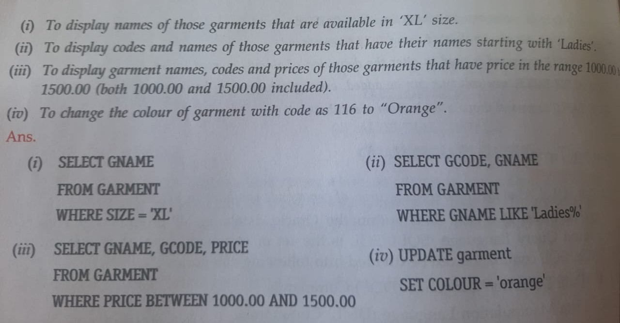

1. Write any five websites that allows online transactions

Ans.

IRCTC, Flipkart, Red bus, Book myshow etc